**SAIMUN 2018 Approval Panel Instructions**

**Approval Panel Introduction**

* Each member of the approval panel has received a user name and password to the computerised system. If you do not have your user name and/or password, please ask a member of the Approval Panel staff for assistance.
* It is vital that you use only your name and password and that you log out when finished using the system.

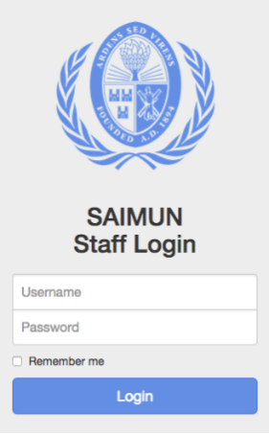**Logging In**

The SAIMUN system can be accessed at [system.saimun.ie](http://system.saimun.ie) at any time whilst connected to the SAIMUN internal network.

To log in to the SAIMUN system, click on the staff login button at the top right of the site and enter your username and password, then click Login.

If your user name and password do not work, please contact a member of the IT staff for assistance.

**A Guide to the Homepage**

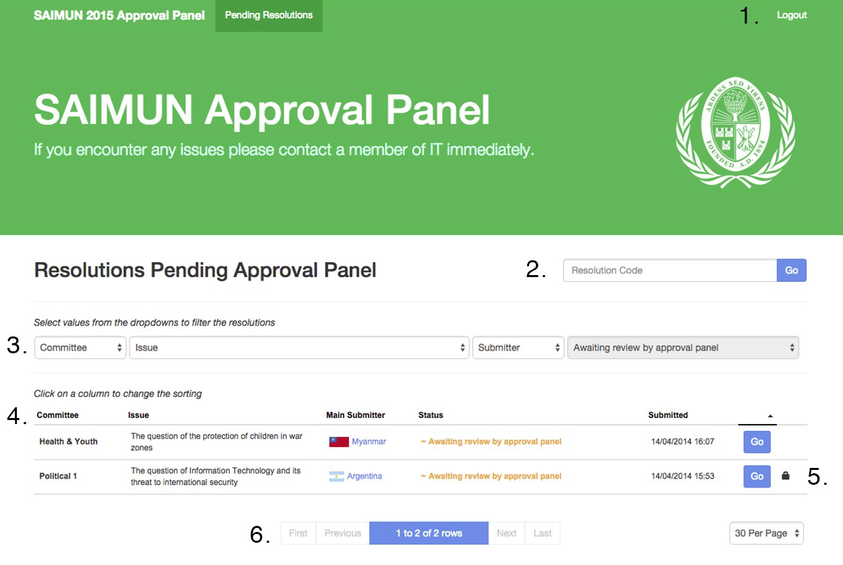

1. Logout button
2. Go directly to a resolution if you know its code
3. View resolutions by committee/issue/submitter
4. Resolution list
5. The padlock symbol (this indicates that someone has locked this resolution and is working on it)
6. Page controls for resolutions more than one page

**Approving a Resolution**

1. 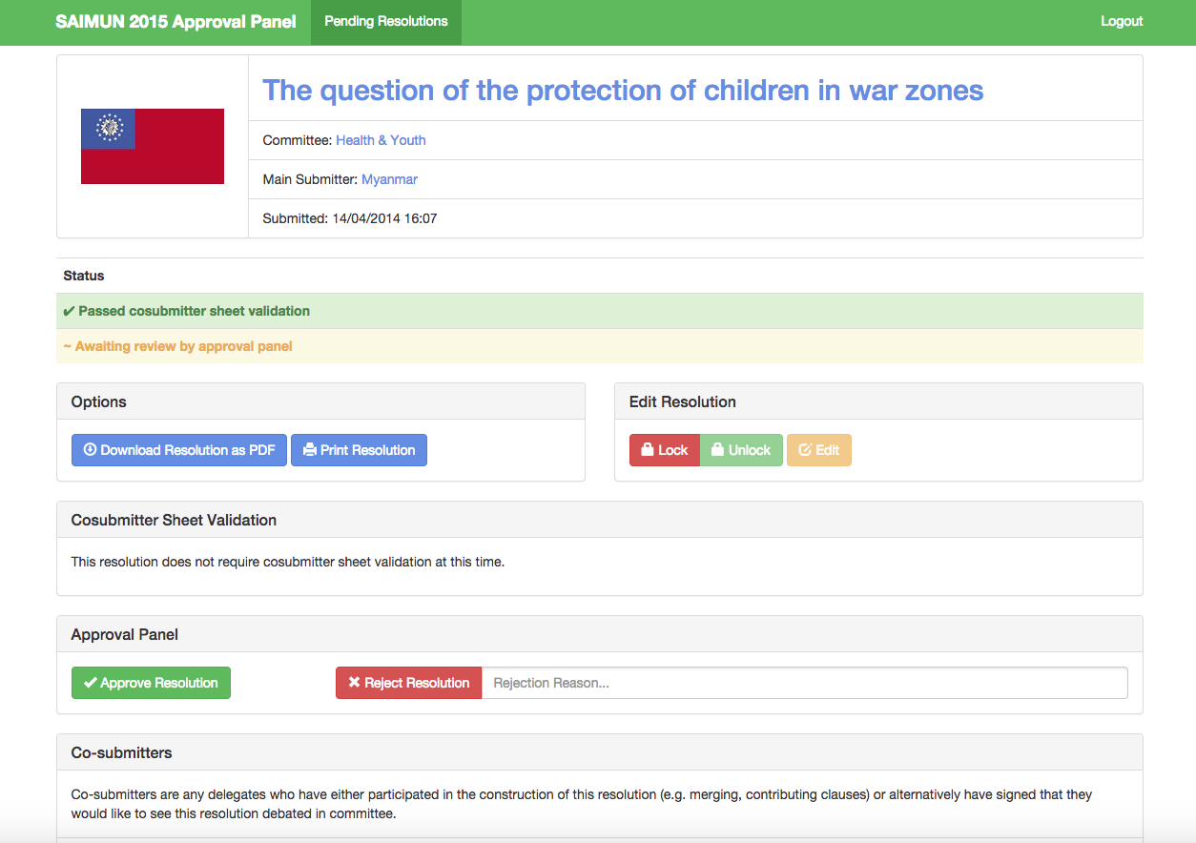To approve a resolution, simply press the Go button beside it and you will be brought to a page similar to the one below.
2. Lock the resolution by clicking the Lock button in red

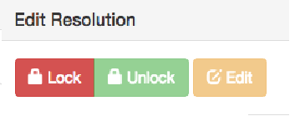**Once you have locked a resolution, no one else will be able to access it**

1. Click the Edit button and the screen below will appear

From this screen you can edit the resolution

(If you need to change the committee or issue, you should ask a member of SAIMUN staff)

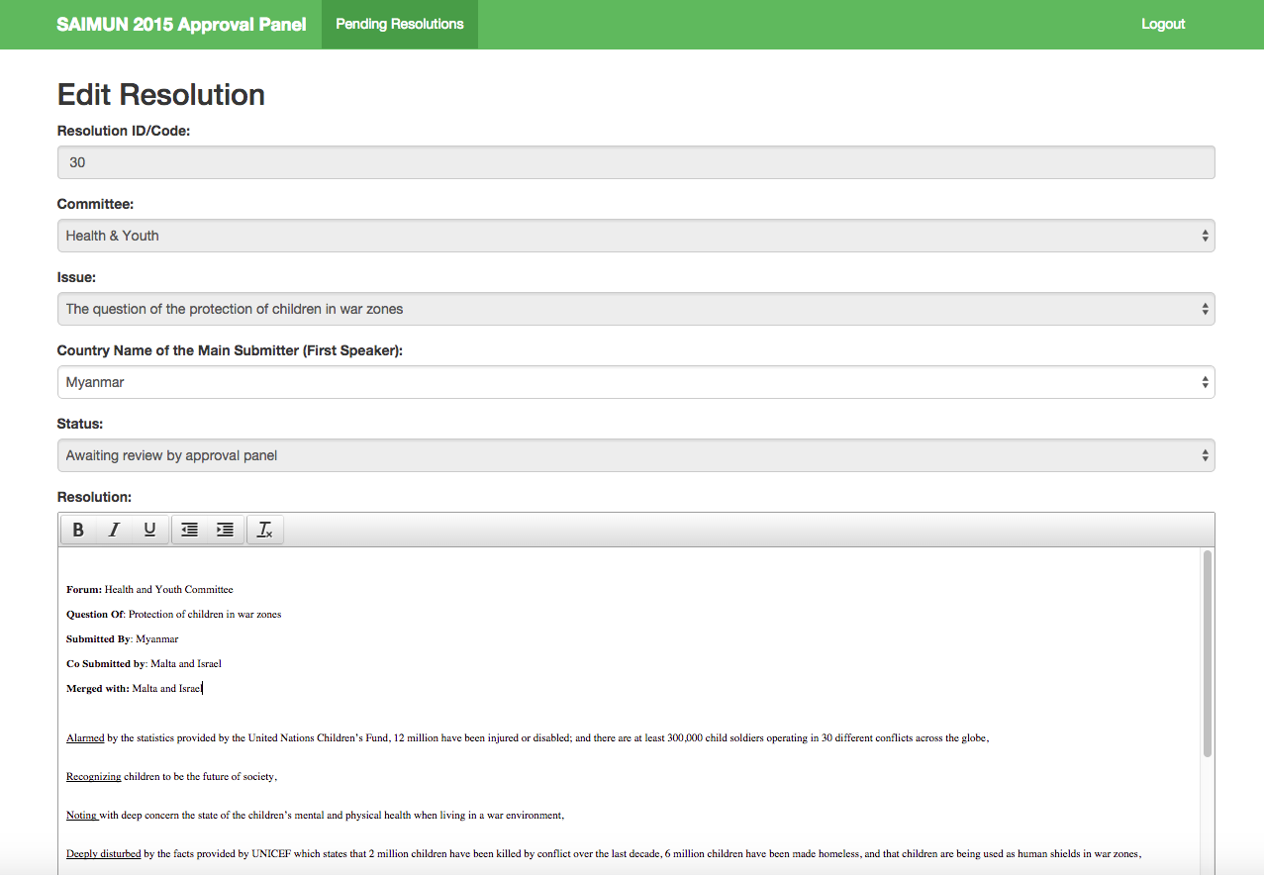

**Points to Note**

* 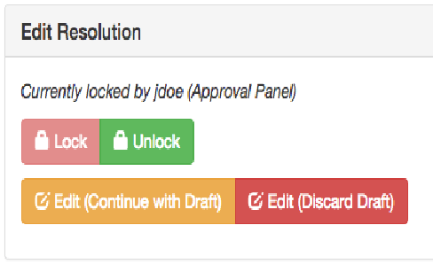The content of a resolution will automatically save your changes as a draft every minute.
* If you accidently navigate away from the resolution screen, don’t worry! When you go back to the resolution, you will see two options: Edit (continue with draft) or Edit (discard draft).
* Choose one of these.

**Approving/Rejecting a Resolution**

* Approving a resolution: simply click Approve Resolution.
* Reject a resolution: you must first enter a reason. **This reason will be public and the delegate that submitted the resolution will see this.** Then click the Reject Resolution button.

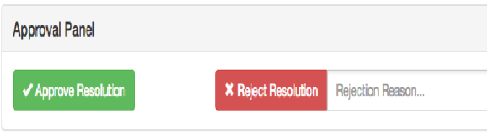

**Please remember to unlock the resolution after you approve/reject it.**

**If you require assistance at any time, please let a member of the IT Staff know and we’ll be happy to assist you.**